# SOFTWARE REQUIREMENT SOLUTION

**Version 1**

**17th September 2021**

1. **Homepage**
   * Logo
   * The Search function(Where user can search all the products)

# Login/Registration

* + - Following detail is required for registration.
      * Name
      * Phone Number
      * Email Id
      * Password
      * Confirm Password
    - Users can login with an Email ID and Password.
  + You can set your contact information such as Email Address and password
  + You would be able to set product with category wise like
  + Banner
    - You can highlight offers, images, videos, etc.
  + Our Products
    - You can highlight your top 10 or top 5 products
  + Footer
    - You would be able to set your company’s information:
      * About us
      * Information
      * Blogs
      * Services (Decoration categories, etc.)
      * Payment methods

# All products

* + You would be able to set all the products by category wise (We will add filters like drink bottles, key rings, notebooks, Tech product, cloths, etc.
  + You would be able to set customization flow.
  + When they will select one particular product, they would be able to customize their product like t-shirt, bottle, key ring or other product
  + The Flow will be

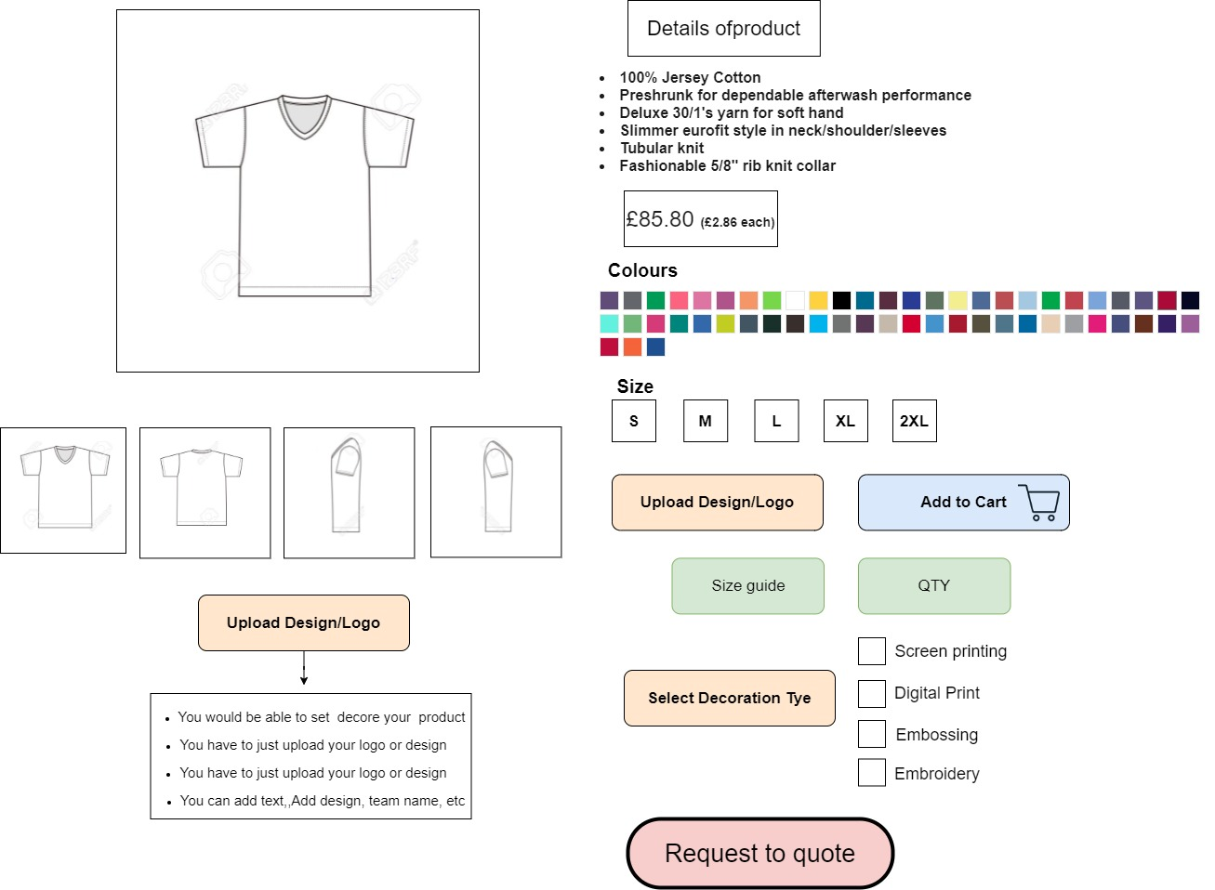

PS: This is only for example you can add othe products such as Drink bottle,Notebook, Mug, Cloths, Key ring, Technical products etc.

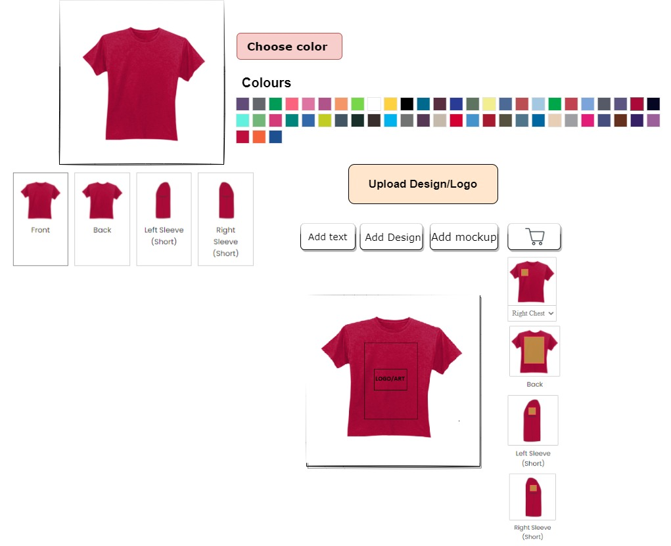

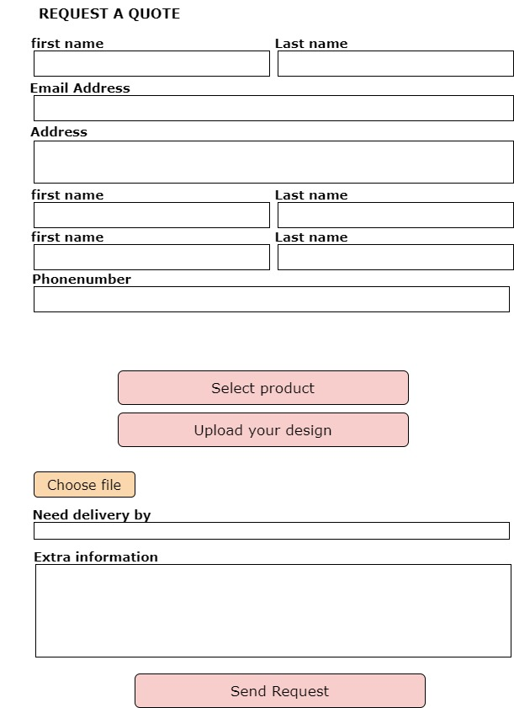

* + User can also save as a wish list or add to cart product for future use
  + Admin can see the request of the user and send estimation via mail or by system

# * Payment flow ( Front End only)

* + After selected a decoration and product admin will be send quotation by user
  + The user can also save as a wish list or add to cart product for future use
  + Admin can see the request of user and sent estimation via mail or by system
  + After that, if they want to purchased it, they can pay by online payment
  + They have to just fill the personal detail and checkout with MasterCard, Visa, Discover, PayPal or other payment methods.
  + After payment user can get a notification from the admin site (Like your order arrives today, your order will deliver that day etc.)

# Providing Services

* + Website Design(HTML,Css, Javascript,jquery)
  + Responsive(Suitable in all devices Mobile, tablet, desktop etc)
  + Testing

# Estimation

* + Cost: $450
  + Duration: 8 to 10 working Days